Documentation

Development of employment levels (geringfügige Beschäftigung):



🡪 many, but not all, Bundesländer have seen an increase in the employment level for low wage work since the wave of refugees

Development of the number of refugees relative to the population in each Bundesland:



Difference in Refugees relative to the Population between 2014 and 2016:

Ein Bild, das Tisch enthält.

🡪 two Bundesländer which would be good for comparison are Mecklenburg-Vorpommern and Schleswig-Holstein as they are very comparable since they are located next to each other and have a comparable size. Also they are on opposite ends regarding the change in refugees per population

🡪 another idea would be to compare Mecklenburg-Vorpommern and Bremen since they took in the least and most refugees relative to their population, respectively. However, one is a city and one is not densely populated so they may not be directly comparable.

Development of refugees relative to the population in Germany and Switzerland:



🡪 we can see that Germany took many more refugees in than Switzerland

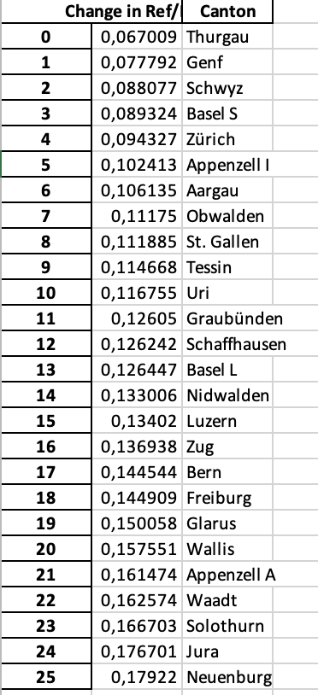

* Genf & Waadt oder Solothurn & Aargau